**Theme 1 : Origins of the salinity**

# **Article 1 :**

| 3 Major types of salinity | | |
| --- | --- | --- |
| **Primary** | **Secondary** | **Climate** |
| come from **parental materia**l (parent rock)  soil formerly **submerged under seawater**  **Inondation of coastline land** | come from human actions  **Hurdles to good drainages** (dykies)  **soil pollution** (fertilizers)  **irrigation** | ↗sea level → ↗ soil salinity  ↗sea level + groundwater overexploitation → intensify saltwater intrusion in coastal and island aquifers  climate change → ↗ evaporation → ↗ salinisation of shallow groundwater |
|  |  |  |

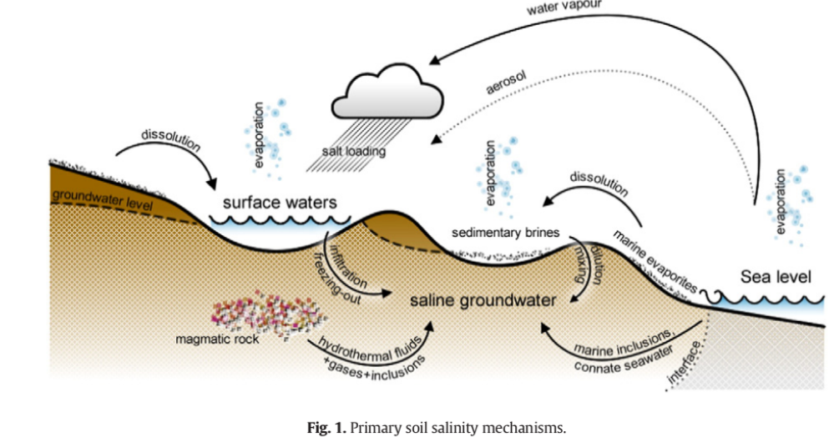

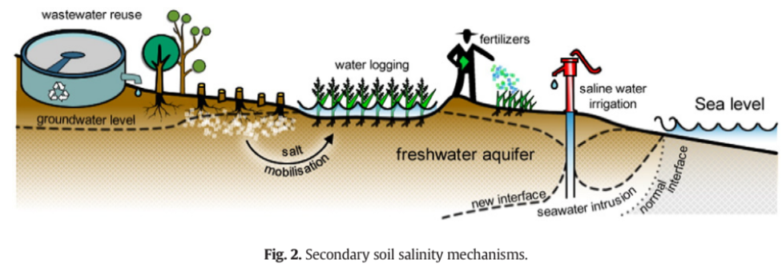

**3. Mechanisms and impacts**

Physicochemical properties for sodic soil : In sodic soil Na+ of salt displace other cations and bind with clay particles.

Na+ hydrolyzation → disruption of link between soils particles

Sodic soil → soils that are more susceptible to erosion

# **Article 2 :**